Orthobicupola

Definition
# Source: AI Source: Provided by: [Data Path: Persons Table -> ID Column: 1, Name_En Column: Motasem Essam] -> From: [ChatGPT] on [7/25/2026]
An Orthobicupola is a polyhedron formed by joining two identical cupolas at their larger polygonal bases, with the two cupolas arranged in the same relative orientation so that corresponding faces of the two cupolas meet in matching pairs.
The prefix Ortho- indicates that like faces meet: triangular faces align with triangular faces, and square faces align with square faces.
An orthobicupola has:
- Two opposite $n$-gonal faces.
- $2n$ triangular faces.
- $2n$ square faces.
- A shared internal $2n$-gonal joining base, which is not part of the external surface.

Geometric Structure
# Source: AI Source: Provided by: [Data Path: Persons Table -> ID Column: 1, Name_En Column: Motasem Essam] -> From: [ChatGPT] on [7/25/2026]
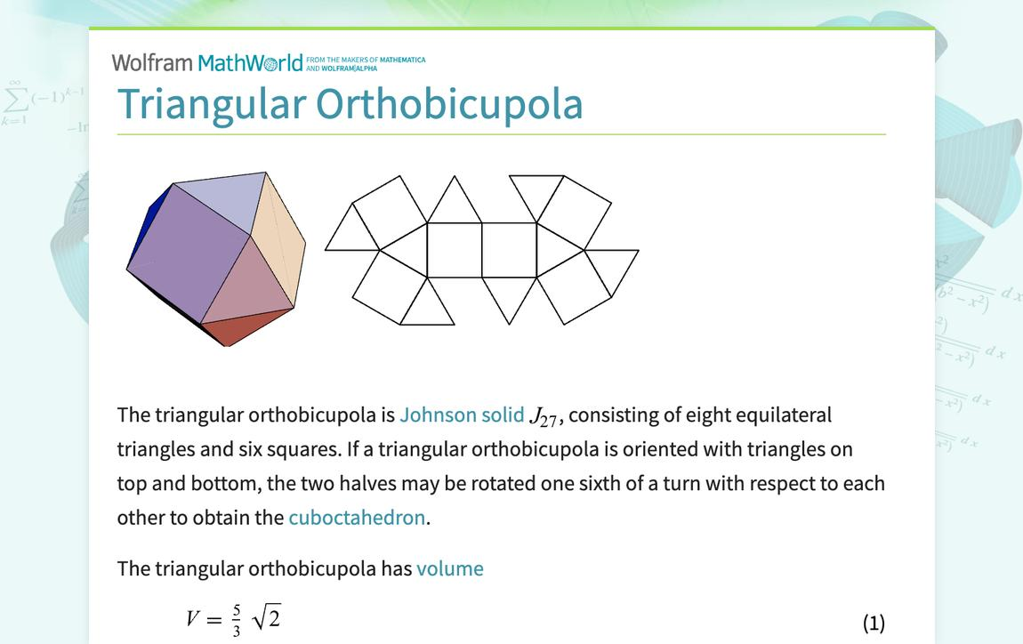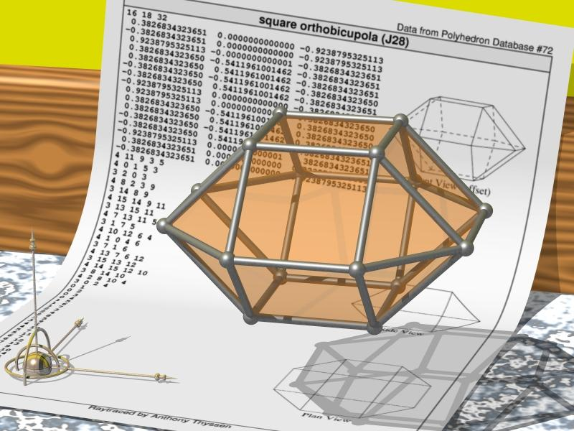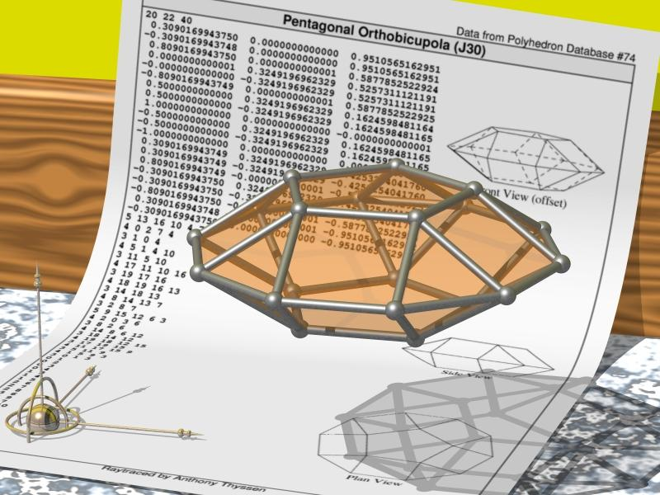
Its main elements are:
- Upper Polygonal Face: The smaller polygon at the top.
- Lower Polygonal Face: The smaller polygon at the bottom.
- Upper Cupola: The upper component of the solid.
- Lower Cupola: The lower component of the solid.
- Triangular Faces: $2n$ external triangular faces.
- Square Faces: $2n$ external square faces.
- Central Joining Region: The shared $2n$-gonal base connecting the two cupolas.
- Vertices: The points where edges meet.
- Edges: The line segments forming the boundaries of the faces.
- Height: The perpendicular distance between the two opposite polygonal faces.

Face Composition
# Source: AI Source: Provided by: [Data Path: Persons Table -> ID Column: 1, Name_En Column: Motasem Essam] -> From: [ChatGPT] on [7/25/2026]
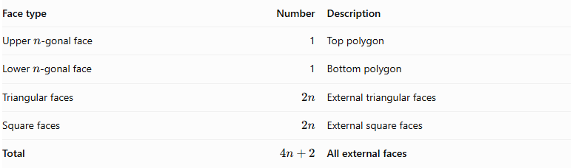
Face type | Number | Description
Upper $n$-gonal face | 1 | Top polygon
Lower $n$-gonal face | 1 | Bottom polygon
Triangular faces | $$2n$$ | External triangular faces
Square faces | $$2n$$ | External square faces
Total | $$4n+2$$ | All external faces
The two larger $2n$-gonal bases are joined internally and are not counted as external faces.

Mathematical Properties
# Source: AI Source: Provided by: [Data Path: Persons Table -> ID Column: 1, Name_En Column: Motasem Essam] -> From: [ChatGPT] on [7/25/2026]
For a generalized $n$-gonal orthobicupola:
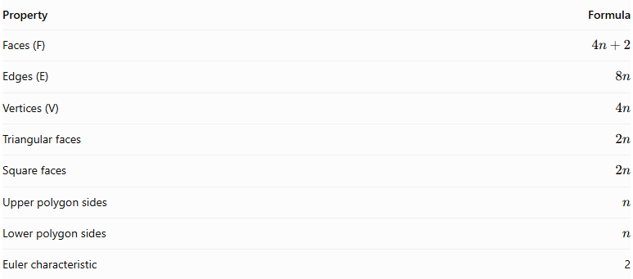
Property | Formula
Faces (F) | $$4n+2$$
Edges (E) | $$8n$$
Vertices (V) | $$4n$$
Triangular faces | $$2n$$
Square faces | $$2n$$
Upper polygon sides | $$n$$
Lower polygon sides | $$n$$
Euler characteristic | 2
Euler's Formula:
$$V-E+F=2$$
$$4n-8n+(4n+2)=2$$

Examples
# Source: AI Source: Provided by: [Data Path: Persons Table -> ID Column: 1, Name_En Column: Motasem Essam] -> From: [ChatGPT] on [7/25/2026]
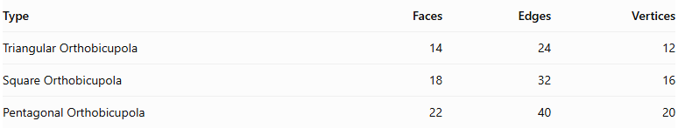
Type | Faces | Edges | Vertices
Triangular Orthobicupola | 14 | 24 | 12
Square Orthobicupola | 18 | 32 | 16
Pentagonal Orthobicupola | 22 | 40 | 20

Types of Orthobicupolas

Triangular Orthobicupola
# Source: AI Source: Provided by: [Data Path: Persons Table -> ID Column: 1, Name_En Column: Motasem Essam] -> From: [ChatGPT] on [7/25/2026]
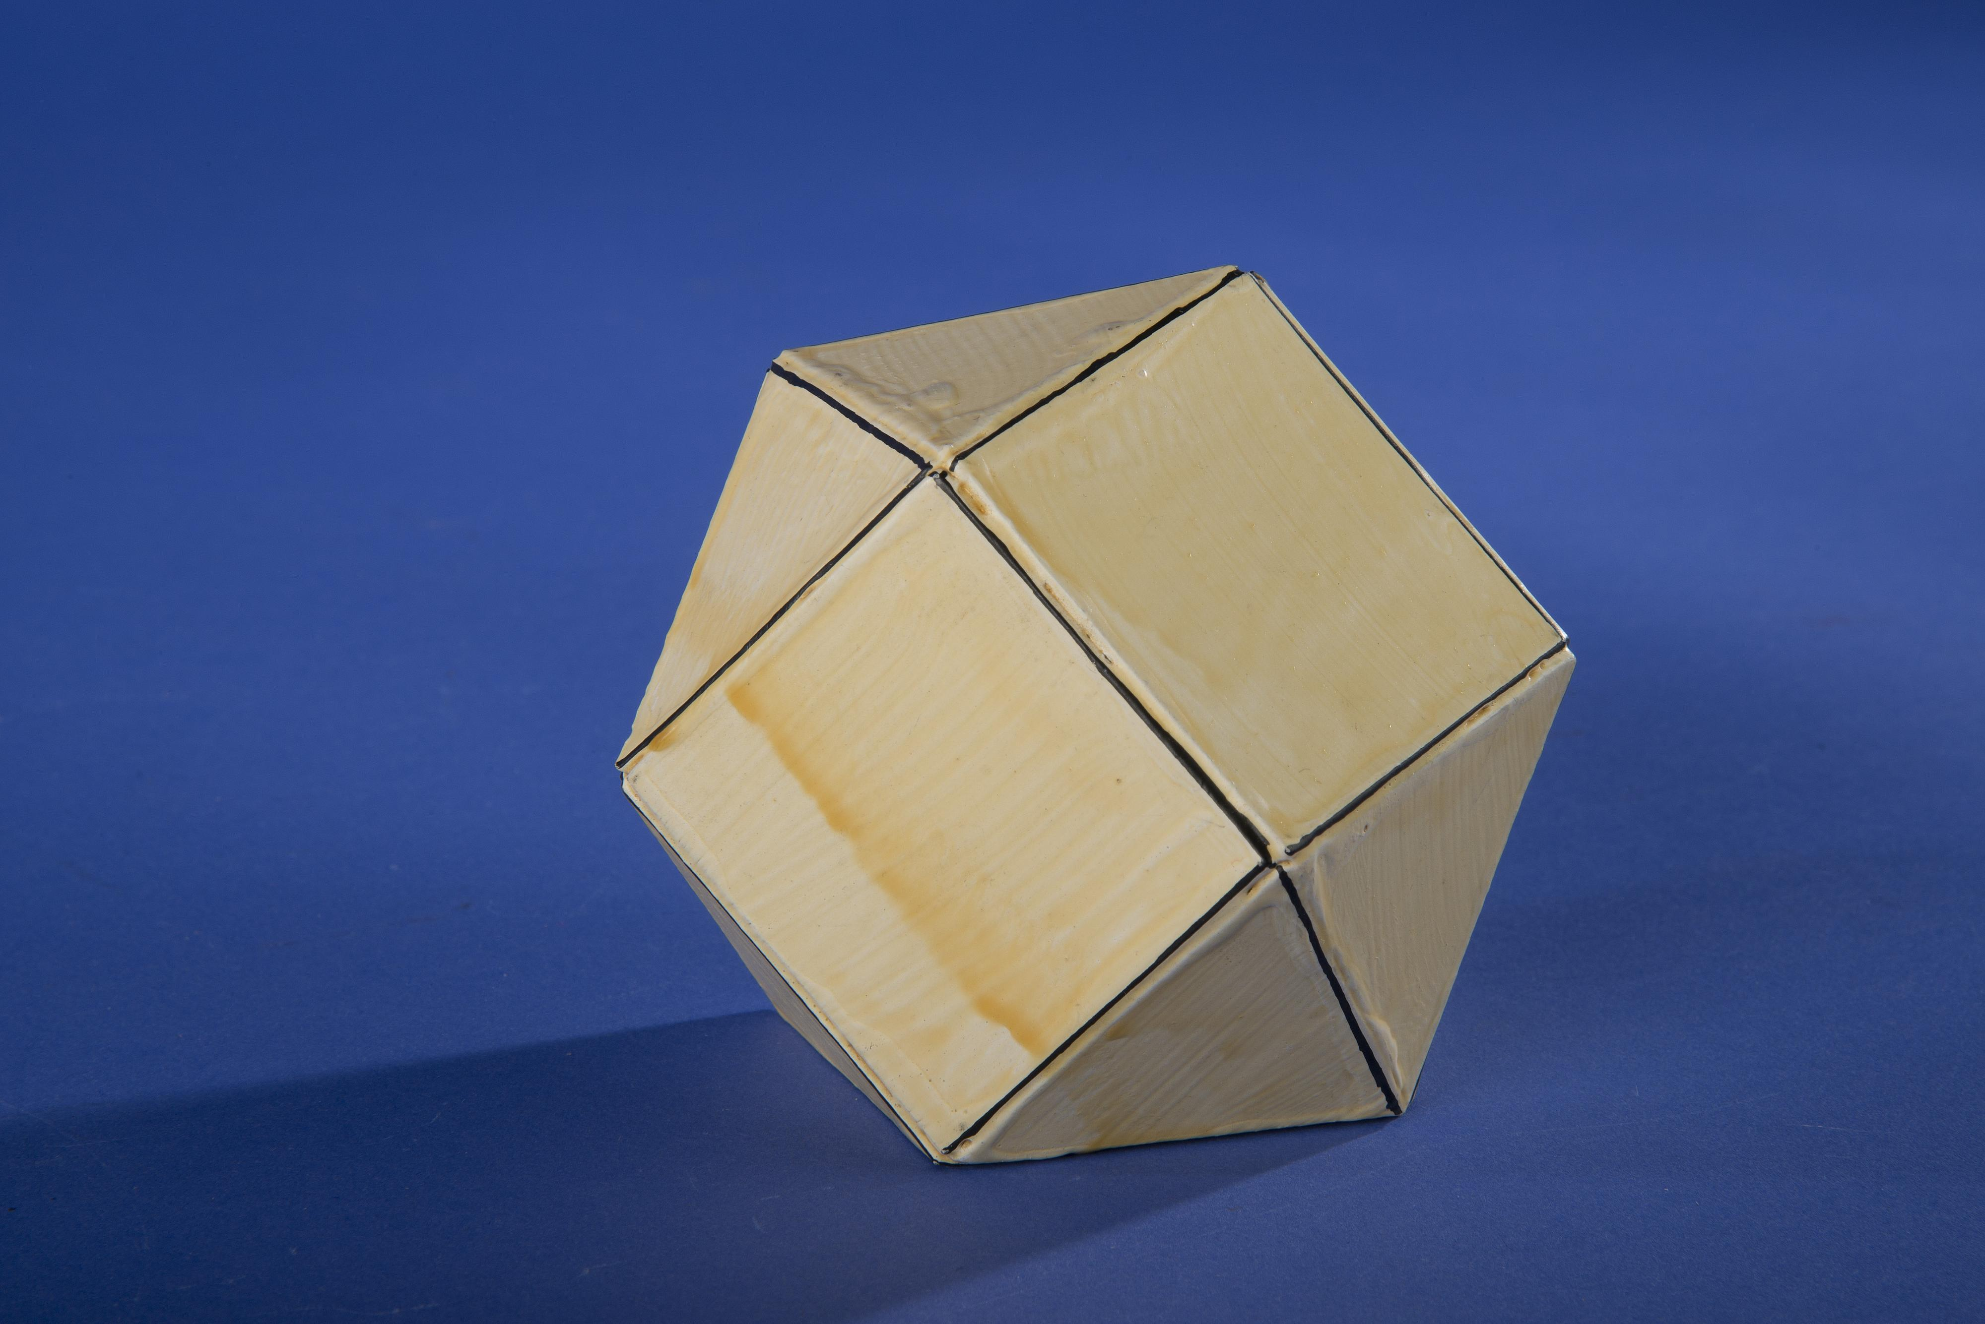
A Triangular Orthobicupola is formed by joining two triangular cupolas along their hexagonal bases, with their orientations aligned.
- 2 triangular polygonal faces.
- 8 equilateral triangular faces.
- 6 square faces.
- 14 faces, 24 edges, and 12 vertices.
- It is Johnson solid $J_{27}$.

Square Orthobicupola
# Source: AI Source: Provided by: [Data Path: Persons Table -> ID Column: 1, Name_En Column: Motasem Essam] -> From: [ChatGPT] on [7/25/2026]
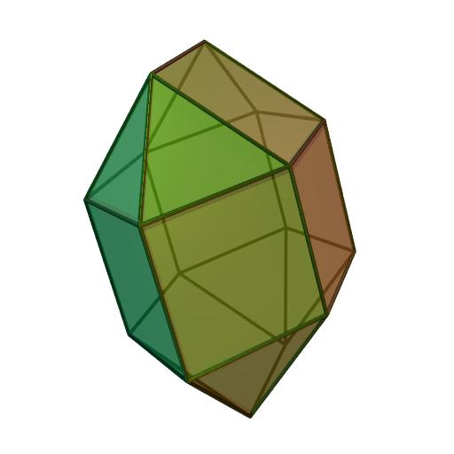
A Square Orthobicupola is formed by joining two square cupolas along their octagonal bases, with their orientations aligned.
- 2 square polygonal faces.
- 8 triangular faces.
- 10 square faces.
- 18 faces, 32 edges, and 16 vertices.
- It is Johnson solid $J_{28}$.

Pentagonal Orthobicupola
# Source: AI Source: Provided by: [Data Path: Persons Table -> ID Column: 1, Name_En Column: Motasem Essam] -> From: [ChatGPT] on [7/25/2026]
A Pentagonal Orthobicupola is formed by joining two pentagonal cupolas along their decagonal bases, with their orientations aligned.
- 2 pentagonal polygonal faces.
- 10 equilateral triangular faces.
- 10 square faces.
- 22 faces, 40 edges, and 20 vertices.
- It is Johnson solid $J_{30}$.

Note: These three are the standard convex regular-faced orthobicupolas among the Johnson solids. The generalized $n$-gonal construction describes the broader geometric family; not every value of $n$ produces a convex polyhedron with all faces regular.

Geometric Characteristics
# Source: AI Source: Provided by: [Data Path: Persons Table -> ID Column: 1, Name_En Column: Motasem Essam] -> From: [ChatGPT] on [7/25/2026]
- It is formed by joining two identical cupolas at their larger polygonal bases.
- The two cupolas have aligned relative orientations.
- Like lateral faces meet: triangular faces align with triangular faces, and square faces align with square faces.
- It has two opposite $n$-gonal faces.
- It has $2n$ triangular faces.
- It has $2n$ square faces.
- It has $4n+2$ external faces.
- It has $8n$ edges.
- It has $4n$ vertices.
- Its central joining polygon is internal and is not counted as an external face.

Construction of an Orthobicupola

Geometric Instruments Used
# Source: AI Source: Provided by: [Data Path: Persons Table -> ID Column: 1, Name_En Column: Motasem Essam] -> From: [ChatGPT] on [7/25/2026]
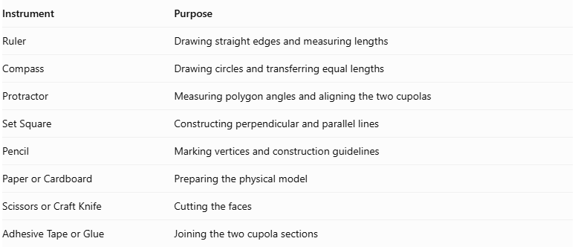
Instrument | Purpose
Ruler | Drawing straight edges and measuring lengths
Compass | Drawing circles and transferring equal lengths
Protractor | Measuring polygon angles and aligning the two cupolas
Set Square | Constructing perpendicular and parallel lines
Pencil | Marking vertices and construction guidelines
Paper or Cardboard | Preparing the physical model
Scissors or Craft Knife | Cutting the faces
Adhesive Tape or Glue | Joining the two cupola sections

Instrument-Based Construction Procedures

Constructing the First Cupola
# Source: AI Source: Provided by: [Data Path: Persons Table -> ID Column: 1, Name_En Column: Motasem Essam] -> From: [ChatGPT] on [7/25/2026]
- Select the number of sides $n$ for the smaller polygonal base.
- Construct a regular $2n$-sided polygon as the larger joining base.
- Construct a smaller regular $n$-sided polygon parallel to it.
- Arrange the smaller polygon's vertices according to the cupola structure.
- Construct $n$ triangular faces and $n$ square faces between the two bases.
- Check the dimensions and matching edges.

Constructing the Second Cupola
# Source: AI Source: Provided by: [Data Path: Persons Table -> ID Column: 1, Name_En Column: Motasem Essam] -> From: [ChatGPT] on [7/25/2026]
- Construct another cupola with the same dimensions.
- Use a congruent smaller polygonal base.
- Ensure that its larger polygonal base matches the first cupola's joining base.
- Preserve the same orientation of the triangular and square face arrangement.
- Check that both cupolas have matching corresponding edges.

Aligning the Two Cupolas
# Source: AI Source: Provided by: [Data Path: Persons Table -> ID Column: 1, Name_En Column: Motasem Essam] -> From: [ChatGPT] on [7/25/2026]
- Position the two larger polygonal bases opposite each other.
- Align corresponding vertices of the two joining polygons.
- Align the corresponding triangular and square face arrangements.
- Ensure that the two cupolas have no relative rotational offset.
- Check that the joining boundaries match completely.

Joining the Cupolas
# Source: AI Source: Provided by: [Data Path: Persons Table -> ID Column: 1, Name_En Column: Motasem Essam] -> From: [ChatGPT] on [7/25/2026]
- Bring the two larger polygonal bases together.
- Match their corresponding vertices and edges.
- Join the two cupola sections along the shared polygonal base.
- Treat the shared base as an internal face.
- Preserve the two smaller polygonal bases as the external end faces.
- Inspect all connections to ensure that the completed solid is closed.

Completing the Solid Drawing
# Source: AI Source: Provided by: [Data Path: Persons Table -> ID Column: 1, Name_En Column: Motasem Essam] -> From: [ChatGPT] on [7/25/2026]
- Draw the two smaller polygonal bases at opposite ends.
- Draw the triangular and square lateral faces.
- Represent the aligned arrangement of both cupola sections.
- Draw visible edges using continuous lines.
- Draw hidden edges using dashed lines where appropriate.
- Check the symmetry and face connections.

Related Geometric Solids
# Source: AI Source: Provided by: [Data Path: Persons Table -> ID Column: 1, Name_En Column: Motasem Essam] -> From: [ChatGPT] on [7/25/2026]
- Bicupola
- Gyrobicupola
- Triangular Orthobicupola
- Square Orthobicupola
- Pentagonal Orthobicupola
- Cupola
- Elongated Orthobicupola
- Gyroelongated Bicupola
- Cuboctahedron

Main Classification
# Source: AI Source: Provided by: [Data Path: Persons Table -> ID Column: 1, Name_En Column: Motasem Essam] -> From: [ChatGPT] on [7/25/2026]
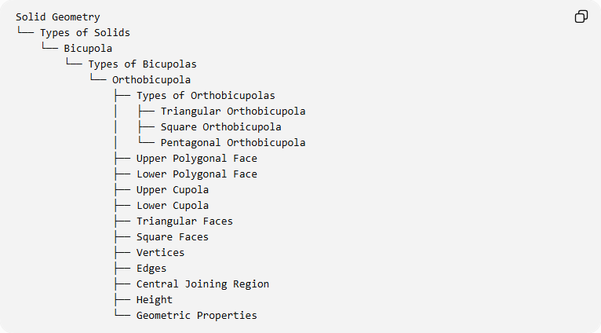
Solid Geometry
└── Types of Solids
└── Bicupola
└── Types of Bicupolas
└── Orthobicupola
├── Types of Orthobicupolas
│ ├── Triangular Orthobicupola
│ ├── Square Orthobicupola
│ └── Pentagonal Orthobicupola
├── Upper Polygonal Face
├── Lower Polygonal Face
├── Upper Cupola
├── Lower Cupola
├── Triangular Faces
├── Square Faces
├── Vertices
├── Edges
├── Central Joining Region
├── Height
└── Geometric Properties

Key Points
# Source: AI Source: Provided by: [Data Path: Persons Table -> ID Column: 1, Name_En Column: Motasem Essam] -> From: [ChatGPT] on [7/25/2026]
- An orthobicupola consists of two cupolas joined base-to-base.
- The two cupolas have aligned orientations.
- Like lateral faces meet at the joining region.
- Its generalized face, edge, and vertex counts are $4n+2$, $8n$, and $4n$.
- The triangular, square, and pentagonal orthobicupolas are Johnson solids $J_{27}$, $J_{28}$, and $J_{30}$.

Conclusion
# Source: AI Source: Provided by: [Data Path: Persons Table -> ID Column: 1, Name_En Column: Motasem Essam] -> From: [ChatGPT] on [7/25/2026]
The Orthobicupola is a bicupola formed by joining two identically oriented cupolas at their larger polygonal bases. It is distinguished from the Gyrobicupola by the alignment of its triangular and square faces. Its standard convex regular-faced examples are the Triangular, Square, and Pentagonal Orthobicupolas.

